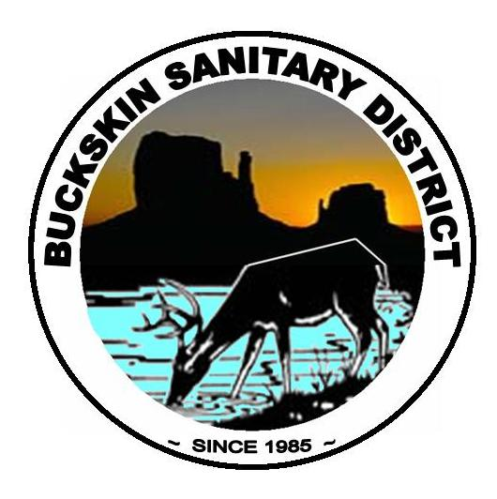
BUCKSKIN SANITARY DISTRICT
P O Box 5398
Parker, AZ 85344

Board of Directors:
Shelly Rohde Gary Hansen Gary Svider William Risen Robert Troxler

Pursuant to Arizona Revised Statute §38-431.02, notice is hereby given to the members of the Buckskin Sanitary District Board of Directors, and to the general public, that the Buckskin Sanitary Board of Directors will hold a Regular Meeting, open to the public, on Tuesday, April 20, 2010, at 5:30 p.m. at the Boat Safety Building Meeting Room, located at 8484 Riverside Drive, Parker, Arizona.

AGENDA

OF THE BUCKSKIN SANITARY DISTRICT
BOARD OF DIRECTORS
Tuesday, April 20, 2010 at 5:30 p.m.
Boat Safety Building, 8484 Riverside Dr., PARKER, ARIZONA

- Call to Order.

- Project Report from Pooled Resources

- Funding Report from Pooled Resources

- District Manager’s Report

CONSENT AGENDA

- a). Approval of Minutes dated 2/9/10, 3/12/10 Regular Meeting, 2/23/10 Special Meeting, Worksession, 3/31/10, & 4/14/10 2010/2011 Budget Worksessions, b). Approval of Accounts Payable dated 3/11/10 - 4/18/10

COMMITTEE REPORT
A. Lateral/connection Issues by JR Pooler
B. “No Free Ride” Ordinance by Paul Harter

REGULAR AGENDA (Discussion and possible action on the following items):

- (Action Item) Approve/Disapprove possible modification of assessments for parcel #311-47-016A, commonly known as the Miller Property from 15 EDU’s.

- (Action Item) Approve/Disapprove possible modifications of assessments for Parcel # 311-66-136, commonly known as the Tony Guadalabene property at 17 EDU’s.

Page 2
Buckskin Sanitary Regular Meeting
April 20, 2010

- (Action Item) Approve/Disapprove Change Order # 10 to Wagner Construction in the amount of $24,996.00 that covers the overage estimated quantities that were approved in Change Orders 6 & 7.

- ( Action Item) Approve/Disapprove Change Order #11 to Wagner Construction in the amount of $5,484.11 which includes the costs to convert the pump motor for lift station #7, adjustment of the odor scrubber coverlid and the added $5.00 per ton AC costs incurred by Combs Construction.

- (Action Item) Approve/Disapprove Application Pay Request #9 from Wagner Construction in the amount of $254,319.69 to be submitted to Rural Development for payment.

- (Action Item) Authorization of payment to Stanley Consultant’s in the amount of $228,024.93 which includes Invoices # 125962, 126919, 127469, 128436, 128750, and 129259.

- (Discussion Item) Discussion to address policies and procedures to be put into place regarding the discrepancies from the Forensic Audit and Financial Audit Reports.

- (Action Item) Approve/Disapprove Membership in the Rural Water Association of AZ in the amount of $400.

- (Action Item) Approve/Disapprove proposal in the amount of $955.73 by Independent Signs & Lighting for signage at the office building at 8832 Riverside Dr. #4.

- Convene into Executive Session
EXECUTIVE SESSION
Discussion and possible action to go into Executive Session pursuant to A.R.S. 38-431.03 (A)(1) for the purpose of Discussion or consideration of any personal information relating to the car allowance of the District Manager position.

- (Discussion or Possible Action Item) Discussion and possible action regarding the car allowance for the District Manager.

- (Discussion/ Possible Action Item) Discussion and possible authorization to enact Budgeted, Non-Budgeted and Emergency Authority Limits for BSD Staff.

Open Comment

Page 3
Buckskin Sanitary Regular Meeting
April 20, 2010

Next Regular Meeting will be Tuesday May18, 2010.

- Adjournment

This notice/agenda was posted at the Buckskin Sanitary District Office located at 8832 Riverside Drive, Suite # 4 on Monday, April 19, 2010, on or before 4:30 p.m.

Posted by:________________________________________________

REGARDING ANY OF THE AGENDA ITEMS, PURSUANT TO A.R.S. §38-431.03 (A)(1), §38-431.03(A)(2), §38-431.03(A)(3), AND §38-431.03(A)(4), NOTICE IS HEREBY GIVEN TO THE BOARD OF DIRECTORS OF BUCKSKIN SANITATION AND THE GENERAL PUBLIC THAT THE BOARD MAY VOTE TO GO INTO EXECUTIVE SESSION, WHICH WILL NOT BE OPEN TO THE PUBLIC, ,FOR THE PURPOSE OF DISCUSSION OF PERSONNEL MATTERS, DISCUSSION OR CONSIDERATION OF RECORDS EXEMPT BY LAW FROM PUBLIC INSPECTION, FOR OBTAINING LEGAL ADVICE FROM ITS ATTORNEY(S), OR FOR DISCUSSION OR CONSULTATION WITH ITS ATTORNEY(S) INORDER TO CONSIDER ITS POSITION AND INSTRUCT ITS ATTORNEY(S) REGARDING PENDING OR CONTEMPLATED LITIGATION. PLEASE NOTE THIS TENATIVE AGENDA MAY BE CHANGED PRIOR TO THE SCHEDULED MEETING. ANYONE INTERESTE IN OBTAINING A COPY OF THE FINAL AGENDA FOR THE MEETING SHOULD CONTACT THE BUCKSKIN SANITATION DISTRICT OFFICE AT (928)667-7197 WITHIN TWENTY-FOUR (24) HOURS OF MEETING. This notice is posted Buckskin Sanitary District Office
NOTE: The items set forth may be addressed by the Board in any order. A copy of the agenda background material provided to the Board Members, with the exception of material related to possible executive sessions, is available for public inspection at the District Office at the address noted above.

